# Project

## Introduction

In 2017, there were approximately 600,000 students taking maths and science GCSE exams. In maths, 31% of these got the equivalent of a 3 (equivalent to a D) or below. There are many programs and apps that solve the problem of having a portable calculator, however, I believe that they could be improved upon to better help students.

In 2014, there were a total of 288,000 students entered for STEM A Levels. Approximately 25% of those students exited Sixth Form with a D grade or below. I think that the difficult mathematics that are included in STEM subjects are a large contributing factor to those who get lower grades. Therefore, I think developing an app that will cater specifically to students will help them improve.

My project aims to solve this problem by creating a scientific calculator Android app that is specifically designed for GCSE students, so they can have access to better tools to enable them to achieve their best possible grades.

# Analysis

## Features and Computational Amenability

The scientific calculator I aim to make will have a multitude of features that will be well suited to being created using a computational approach.

One such feature is that the calculator must be able to perform basic arithmetic operations following the rules of BODMAS. This feature is amenable to a computational approach because using the mathematical operations can be calculated much quicker and with much more reliability compared to the traditional methods of using a pen and paper which can be very prone to mistakes.

Another feature important to this project is to have the calculator in an Android app because it provides a degree of portability and ease of use that is very important for the app to be successful. This feature lends itself well to computational methods of solving because using a computer is the only way to provide an Android app to the users.

This project will also have the capability of having some common maths and science equations loaded where the students can input their variables into the calculator to solve the equation to help students as they are revising to check their answers. These inbuilt equations will also contain walkthroughs to manually solving the equation and revision tips.

This is amenable to being solved with a computer because the average phone has plenty of storage to hold all the information required to store different equations. It’s suited to a computer because it is compact and should be intuitive and easy to use, unlike traditional methods such as keeping the information stored in, for example, a revision book because they are heavy and sometimes difficult to navigate. This makes my approach of using an app beneficial to the user because it streamlines their process of work and revision.

I also hope, if possible to have some basic graph functionality where the user can enter linear, quadratic and cubic equations into the app and the user will be provided with a graphical representation of that equation. This feature is important and will be solved easier with a computer because drawing one with a pencil will take much longer and is more vulnerable to errors.

## Stakeholders

This project has multiple stakeholders which are listed below with their requirements:

1. **Students;** specifically, they will be students in Year 10, 11, 12, and 13 currently taking the GCSEs and A Levels. They will make up the majority of my potential user base. This stakeholder will have a high interest in this product because it will be designed specifically for them.

Requirements:

1. This stakeholder will have the main requirement of an Android phone with at least 2GB of storage and at least 3GB of RAM so they can store and run the program.
2. Another requirement for the students is the compatible Android version so the app will run on their phones. I will be developing this program to be compatible with either Marshmallow or Lollipop as these are the most popular versions with 32% and 27.7% usage share respectively as of October 2017. This will give the project the largest potential user base possible
3. Another important requirement is the correct aspect ratio so that the program will be presented correctly and be properly functional.
4. **Teachers;** these are another important stakeholder because the teachers must be aware and knowledgeable about the program so that they can introduce it to the students.

Requirements:

1. The main requirement for teachers to have is a phone with the correct version, either 5.X or 6.X. This will enable them to access the program as it will not be compatible with less popular versions as that would take too much time to program.
2. Another requirement for the teachers would be for their phone to have enough RAM and storage space to be able to run. However, it is unlikely for the program to take up a lot therefore, an average phone should have more than the capacity to run the program.
3. Also, teachers will need their phone to have the correct screen resolution, so the app is displayed properly on the device.
4. Another important requirement is an internet connection to enable the stakeholders to download the app from where it is hosted, for example, the Google Play Store.
5. **Parents;** this is potentially the least sizable stakeholder but are still important because the parents will need to have access to the app because it will enable them to help their children with their schoolwork where they may not be able to otherwise.

Requirements:

1. A phone with a minimum of 2GB RAM and 4GB storage to enable the stakeholder to be able to use the app properly.
2. Their phone would also need to have a compatible screen resolution that will provide the display for the user that makes the app easily readable.
3. Another requirement is an internet connection, so parents can download the app from where it’s hosted, and also download updates if they are made to ensure that their app is the most recent version possible.
4. The parents will also need their phone to have the correct version, so the app is compatible with their phone.

## Research of Existing Solutions

During my research of this problem, I have found many different solutions that solve the problem, or at least partially solve it. The various solutions achieve different levels of success and therefore, I will be analysing different apps.

### 1.3.1 HiPER Scientific Calculator

This is the first example of a very successful solution that I came upon. The HiPER Calculator is presented in the traditional scientific calculator form and is very easy to interpret.

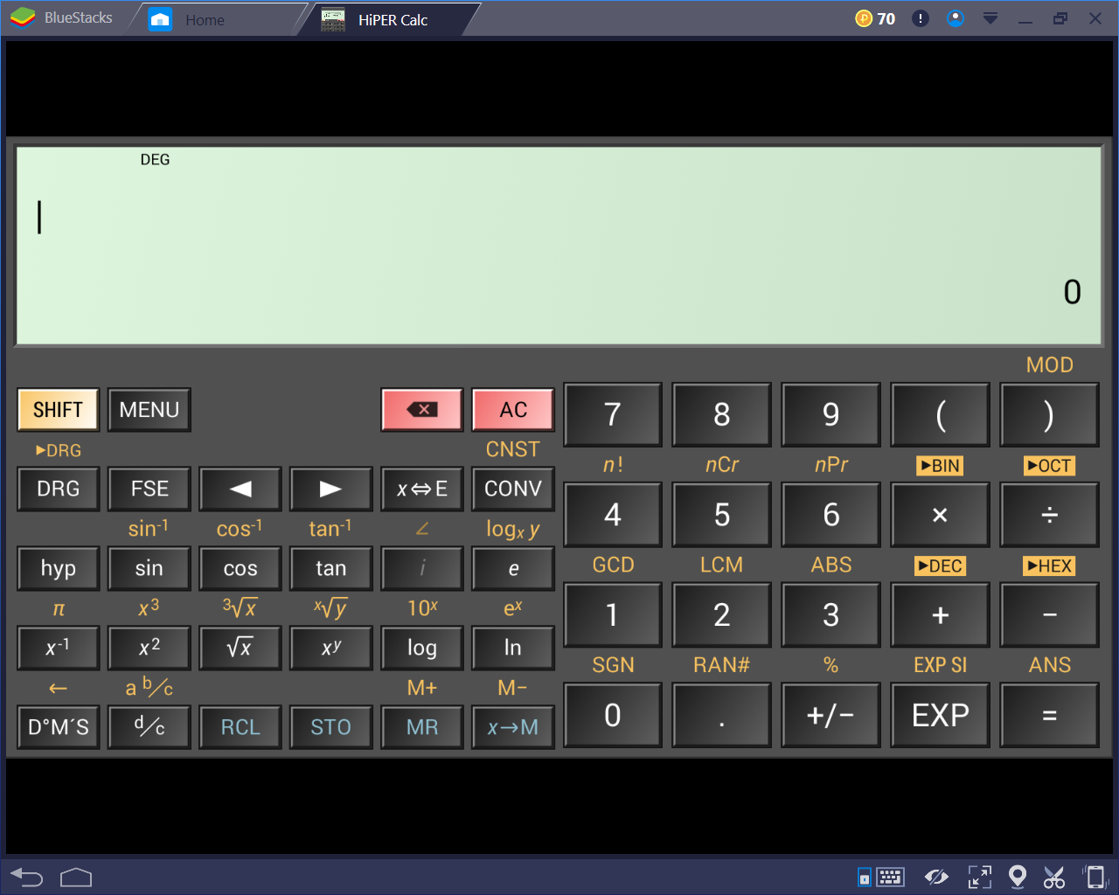

*The basic layout of the calculator*

This app has many positive points about it. For example, it’s usage of the traditional layout means that the user’s will instantly be able to interact easily with the app.

The main positive point about this app is that it performs very well and is responsive to user inputs which means that it’s quick and easy to be used. This app covers all the basic features and functions such as conforming to BODMASS, basic trigonometry, surds, powers, etc. However, the calculator also contains inordinate amounts of other, more niche features that make this calculator much better than the rest on the market.

An example of this is the large amount of hidden functionality that it contains behind different menus. For example, it has the ability to convert between almost any units:

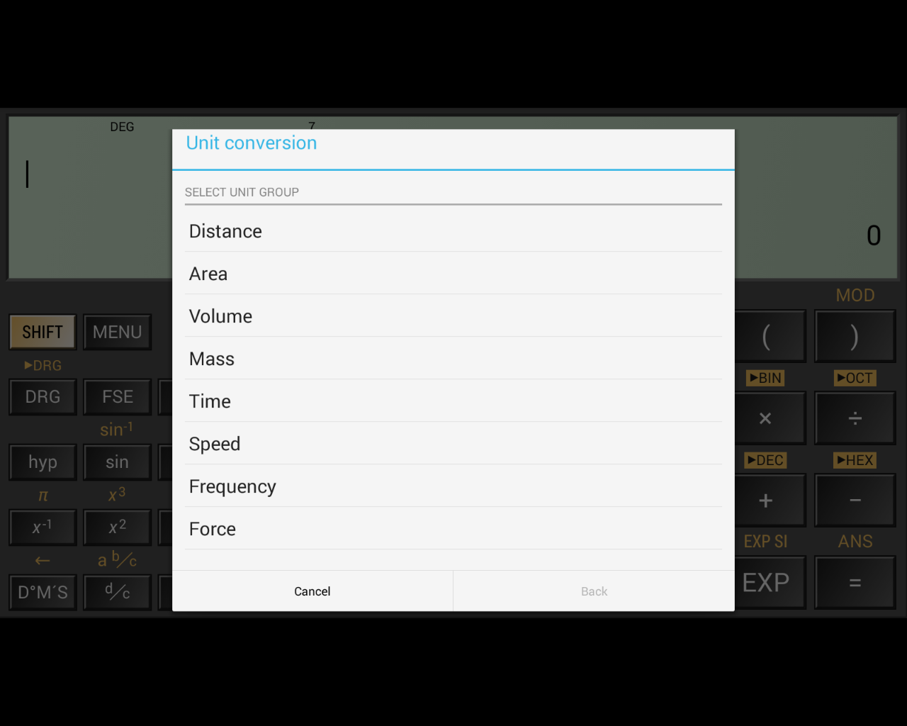

*The different possible conversions*

Other features like this include the storage of common constants that are used in scientific fields.

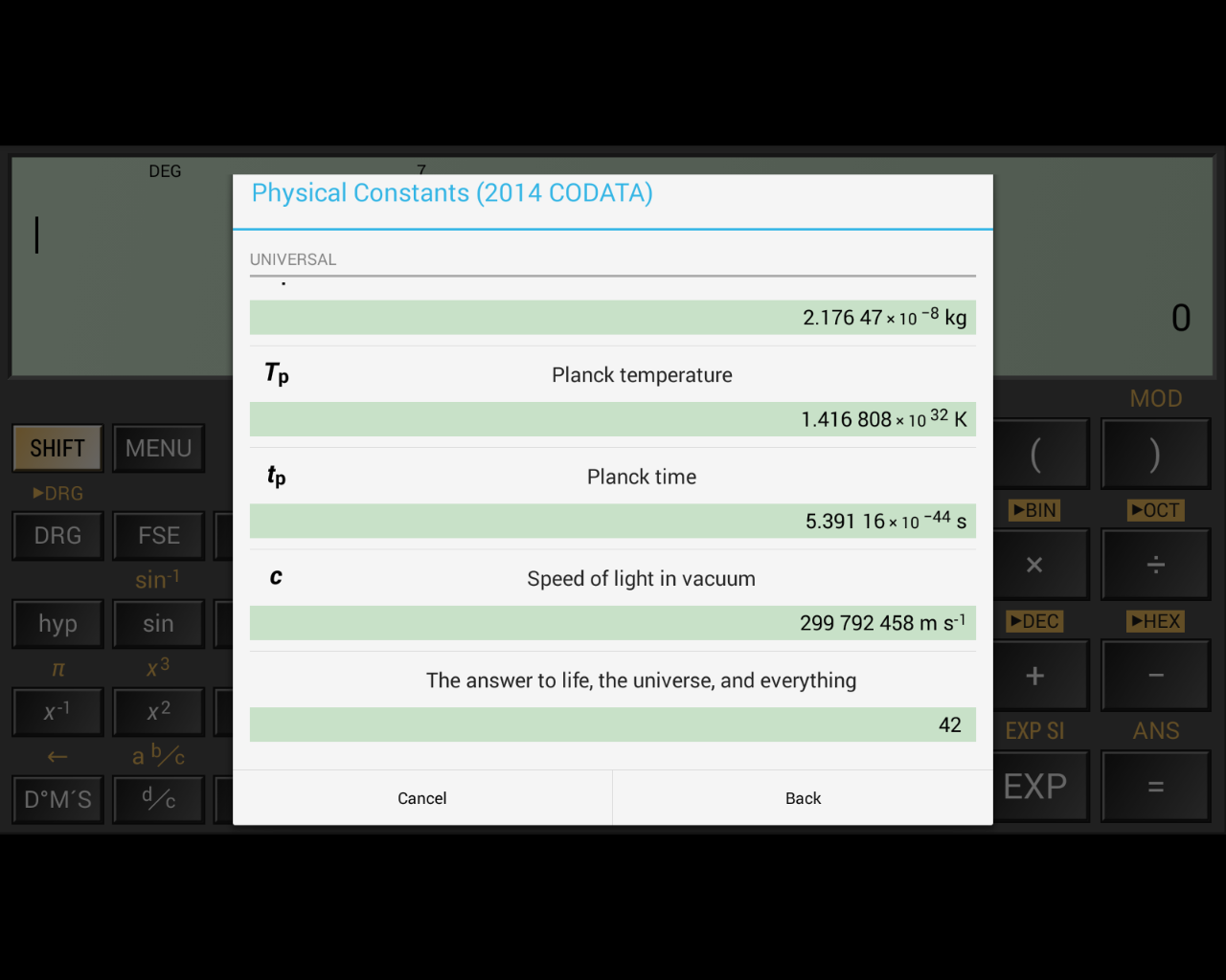

*Different possible constants – there are many more*

This feature is incredibly useful for students as it reduces the amount of time it takes to complete calculations which can be especially useful in certain situations, for example tests. I will be almost certainly adopting this feature in my own project because I believe that this improves the usability of the calculator a lot.

However, I will make my own changes to this because as my own calculator will be specialised towards students in the years. Because of this, I will remove some of the constants as they will not be used up to GCSE and therefore will be useless.

Also, I will be altering the constants to fit in line with the exam’s own values. For example, the speed of light in vacuum is 299,792,458ms-1, but in exams the value is taken to be 3.0x108. Therefore, it is counterproductive to GCSE students because they will receive a slightly incorrect value which could result in rounding errors in their calculation, leading to a loss of marks.

However, this app does also come with a relevant flaw in that the user cannot store numbers as variables for ease of use. The memory storage in this app is reduced to M, and 0-9:

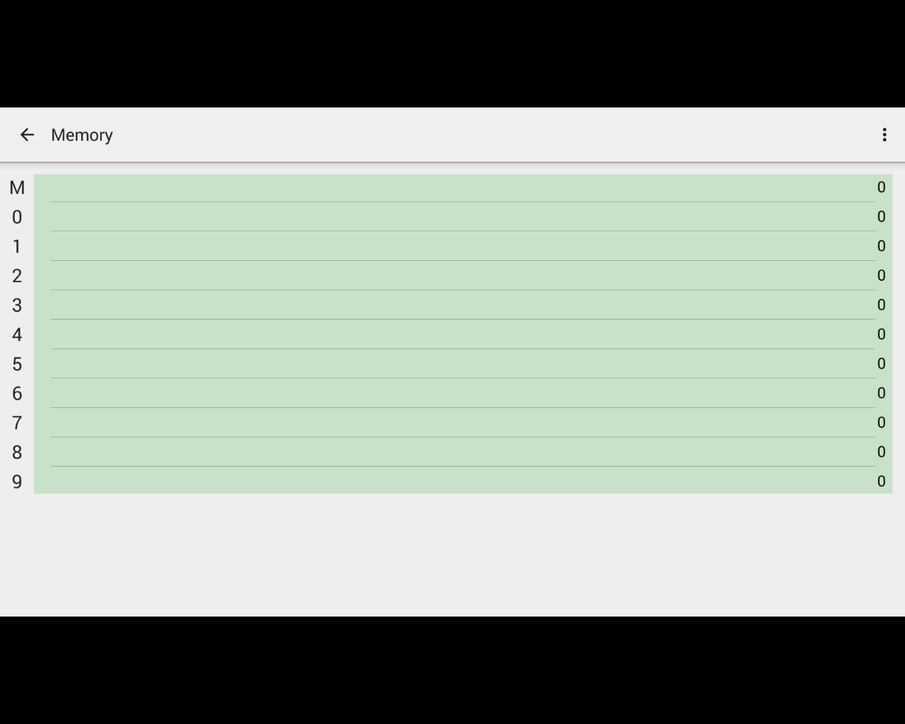

*The calculator’s storage capacity*

I believe this is a major flaw in the calculator because the ability for the user to store their own preferred values in variables is very useful to make the use of the calculator more efficient. Also, the added customisability it provides means using the app becomes more intuitive.

The HiPER Calculator also has the functionality to convert numbers between different representations, such as binary, hex, and denary. I think this feature can be very useful, especially to particular students, such as ones taking Computer Science. This feature is further extended past just simple conversions by having modes for different base number systems.

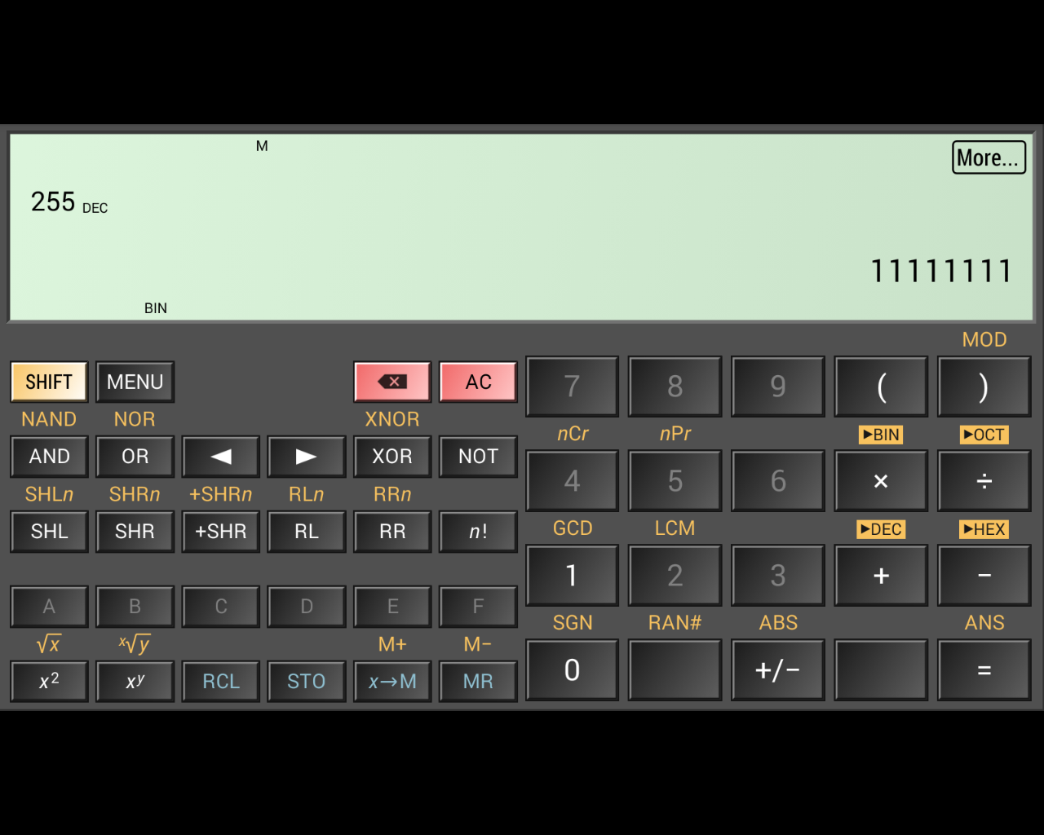

*The calculator in the binary mode*

As the screenshot shows, 255 has been converted to 1111111, and the app has entered the ‘BIN’ mode where the features are different. Prominent examples of this are all the keys on the number pad except ‘1’ and ‘0’ are disabled. The letters from A – F are also enabled when ‘HEX’ mode is enabled. Further features include the inclusion of logical operators such as ‘AND’, ‘OR’, etc. which would be very useful for the user when performing binary calculations.

Other helpful features include things like the ability to copy the output to the clipboard by tapping on the number. The app also has the functionality to display in depth details about the calculations the user is performing. 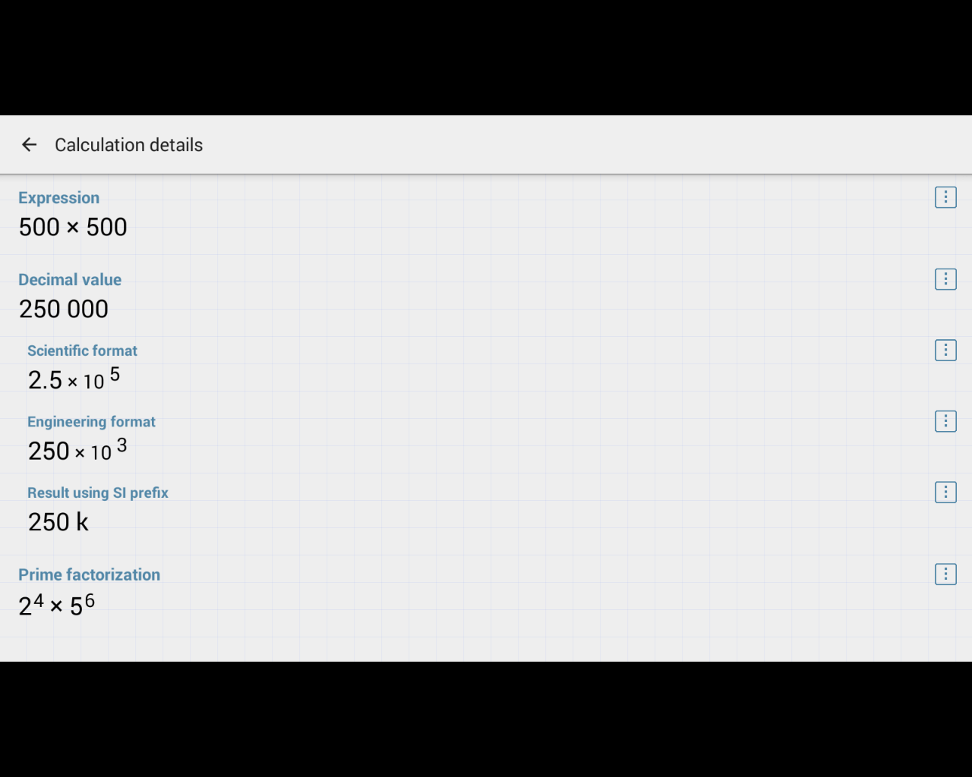

*The output of the ‘More’ button*

As shown in the above screenshot, by clicking on ‘more’, the user is presented with further details about the calculation which involves things like displaying the result in standard form or with different prefixes.

These features and other ones like them are things I would like to include in my final project, however, they are considerably less important than other aspects of the app because while they are helpful, I feel that they are not as necessary to the calculators overall functionality. There are also some features that are useful, but not necessary in my own project, such as the functionality for complex numbers because they are not introduced until A Level and therefore would be pointless in my project.

This calculator also has many benefits other than it’s many features, for example, the app itself is presented in a very clean and uniform way that makes it enjoyable to use as opposed to others on the market which can tend to be gaudy and unprofessional. A good example of this is the app’s menus:

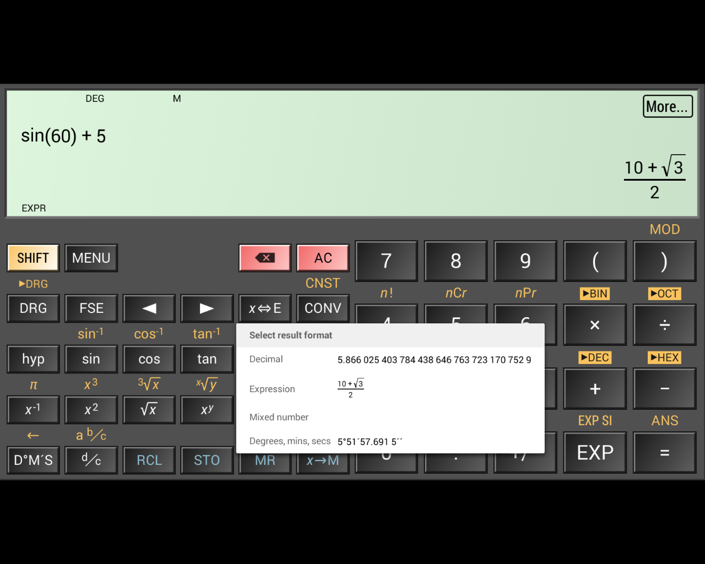

*The calculator displaying different formats for the result.*

In my opinion, the presentation of the app and its different menus is very sleek and minimalist which makes using the app easy and intuitive.

There are also other benefits to using this app as opposed to others relating to it’s presentation. For example, there are choices in the menu for different layouts. This is an important feature because there is a risk for users with uncommon device sizes to have the app be presented with a distorted view that can block off some buttons and features that limit the apps usability.

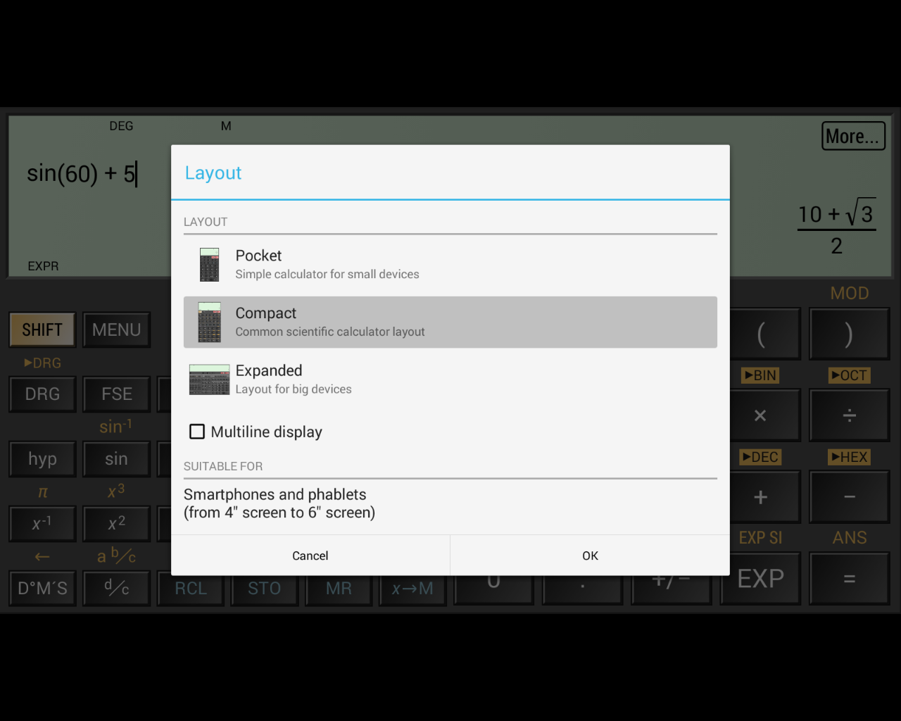

*The different layout options*

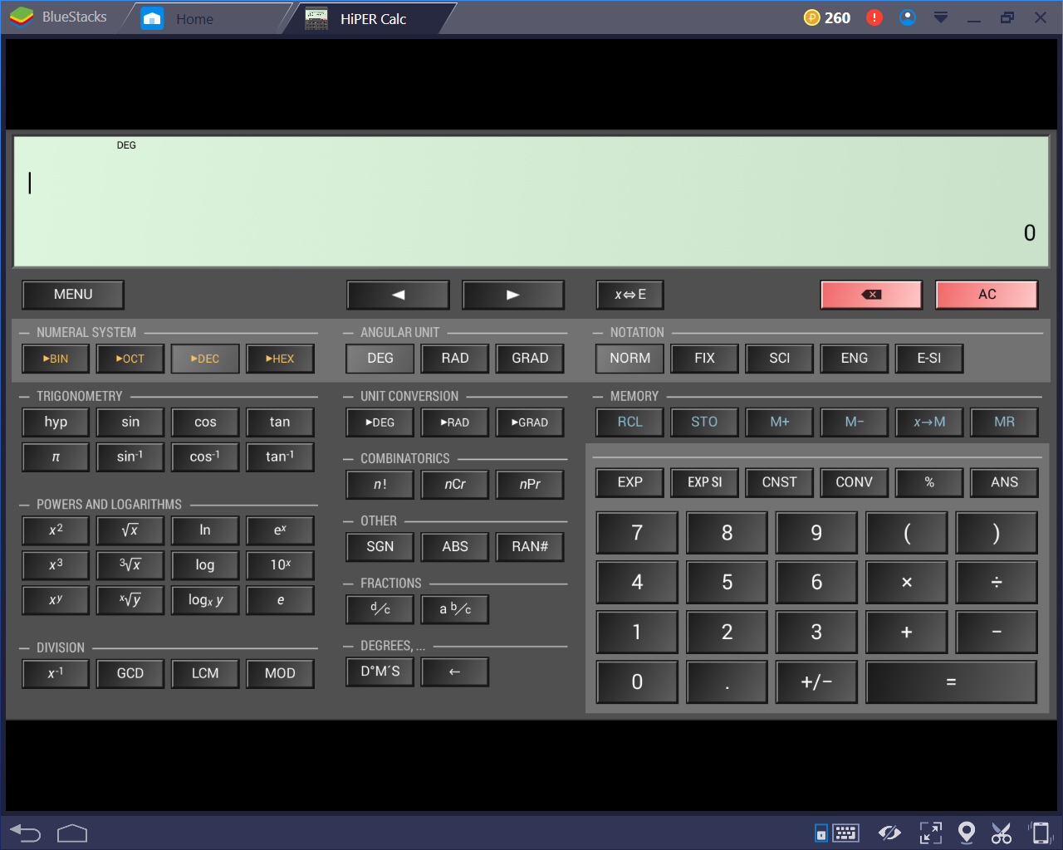

*The layout mode for tablets*

I will attempt to include this feature in my own project because it allows a larger percentage of users to access the program and therefore become more useful to a larger number of people.

Another helpful feature that this app includes are the tips that come up when the user accesses certain, more nice or complicated features. 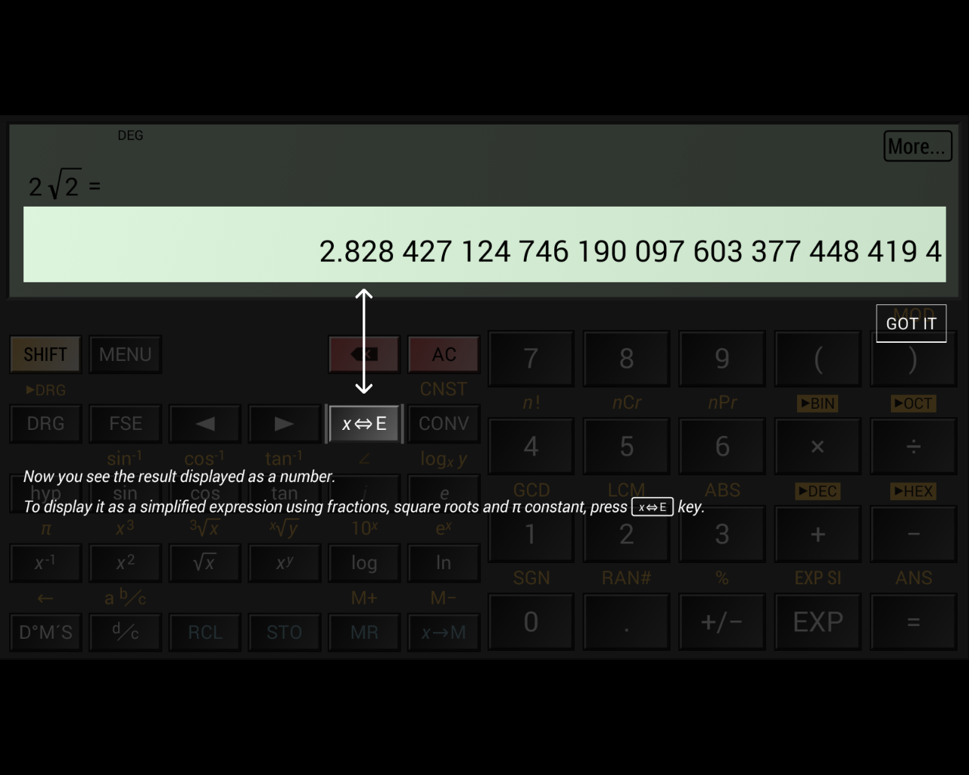

*A tip introducing the user to converting between different displays*

This feature makes the calculator more accessible to users with different levels of knowledge and experience with using scientific calculators. This will be especially important in my own project because increasing accessibility to a higher proportion of users means that more students will be able to benefit from the app. Therefore, this will certainly be a feature that I will be implementing into my own project. I will focus the use of these tips on underutilised features such as the memory storage because it’s important not to bombard the user with notifications as it can annoy the user and so make the app undesirable.

This app also has a very large range of settings for different parts of the program, such as formatting and the display.

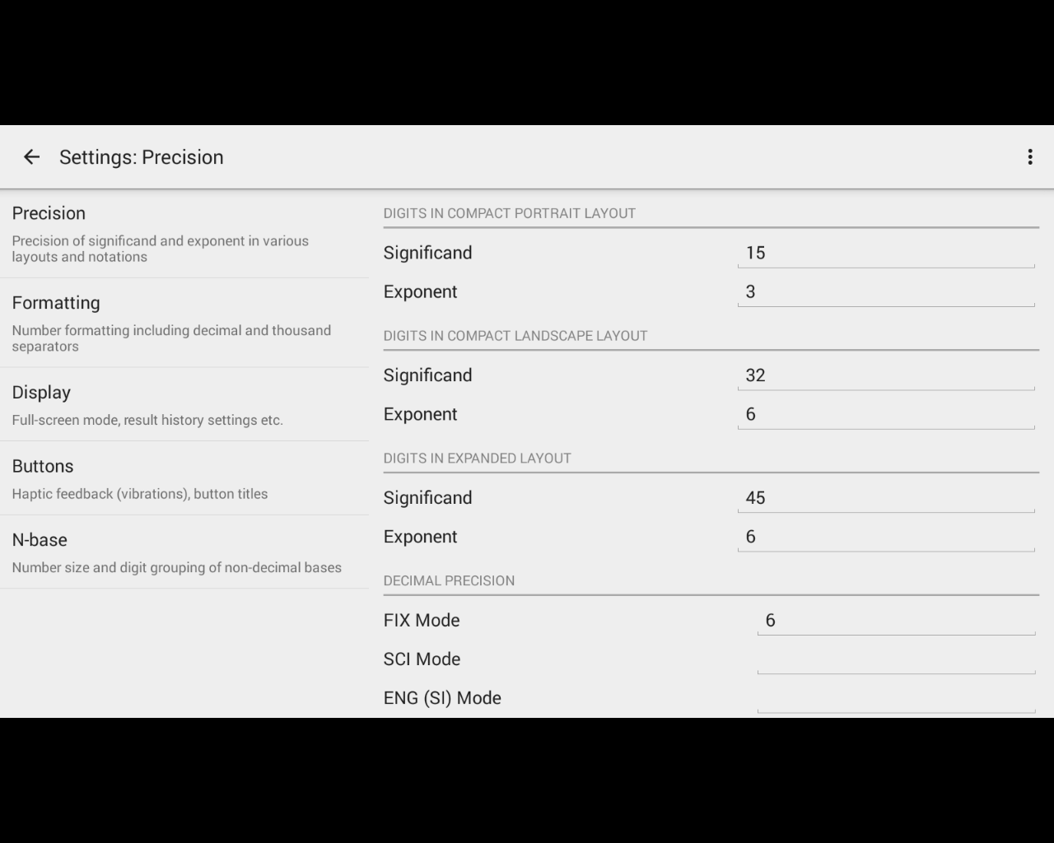

*The different settings for ‘precision’.*

The range of settings for the calculator provide a good benefit for using the HiPER Calculator over other apps because it offers a large amount of customisability, making the app easier for the user to interact with and understand.

This app has other features designed to heighten its level of understandability such as the larger range of error messages for different situations.

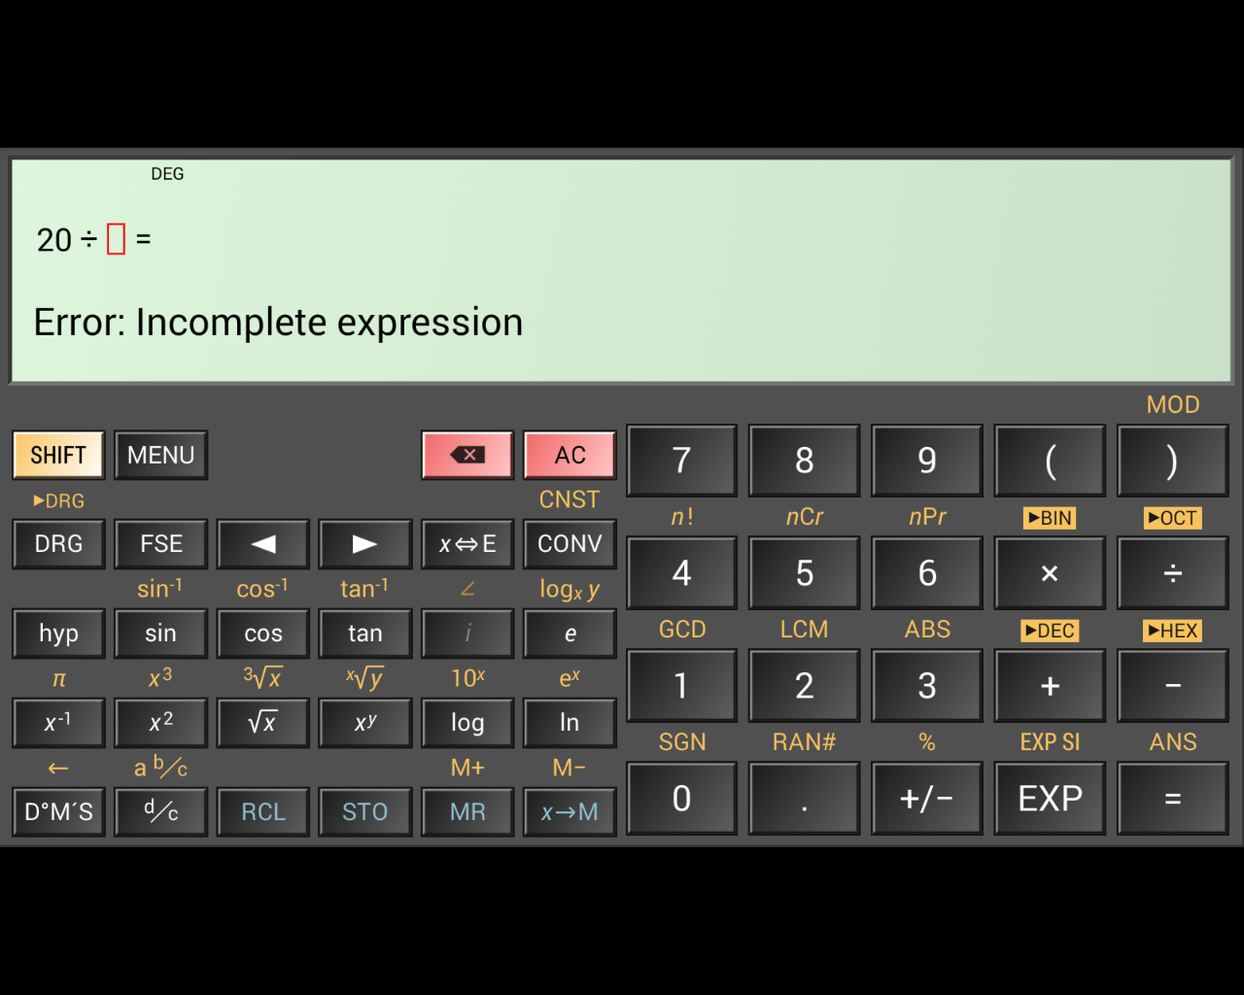

*The error that appears when an expression is unfinished*

This feature is designed to help the user and make the functionality of the app easier to use and understand because the error messages are more descriptive than tradition calculators which would simply output ‘SYNTAX ERROR’. The traditional calculators are less detailed therefore require the user to take longer to fix their expression, whereas the HiPER Calculator has a detailed error message and even highlights the area where the error occurred.

This, and features similar to it such as the calculator auto-completing the expressions in some situations such as a missing bracket or unused decimal point improve the calculators usability by streamlining the process for the user.

### 1.3.2 ColorFul Calculator

This app is an example of a less successful, while still functional calculator. The presentation of this calculator is lacking, especially in terms of a professional setting.

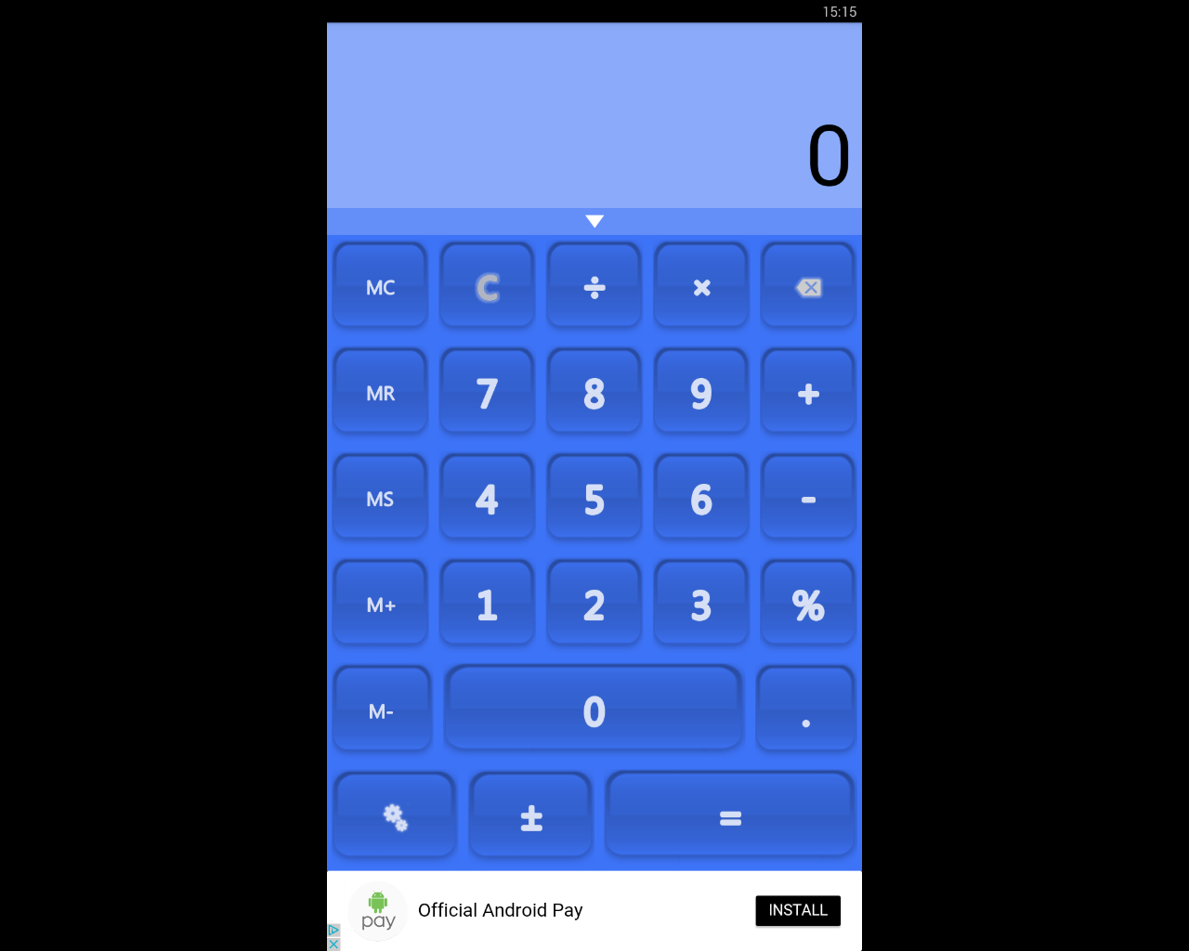

*The base view of the calculator*

While this app does cover all of the very basic functionality, such as the four basic operations, capability for percentages, and memory storage. However, the app does not extend much beyond that. For example, although the app does contain the ability to store values in the memory, there is only space for a single number.

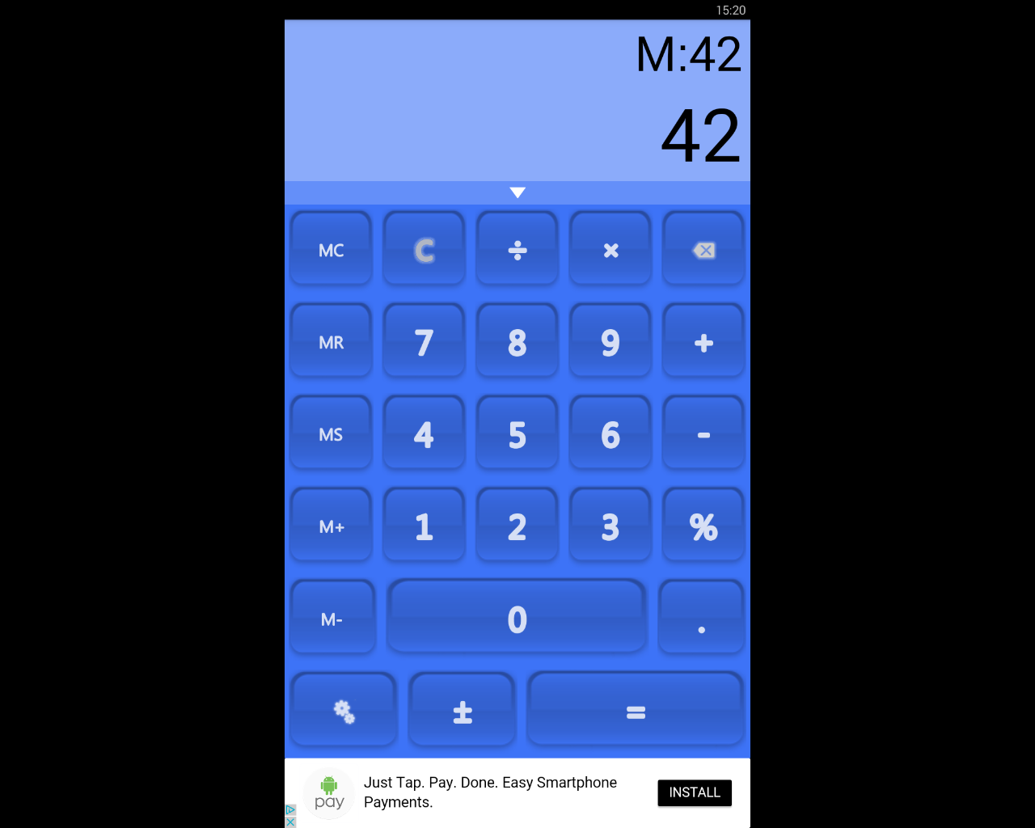

*The value ‘42’ is stored in the memory*

Due to this lack of any major functionality, the app is much less successful when it comes to the user performing calculations that are more involved than operations on a couple of numbers. Another disadvantage to this app is that when inputting the expression, the calculator does not display the user’s input. This means, if the expression is longer than a few separate numbers, it can be awkward to remember what the user has entered to the calculator, meaning it is easy to make mistakes.

Another disadvantage due to this flaw is that if the user gets an incorrect output, they cannot de-bug their own expression to find where the error occurred because it is not displayed to them.

Furthermore, the app contains advertisements which can be very intrusive based on their location. As shown in the screenshots above, the adverts are placed below the calculator, just below the ‘equals’ sign. This placement could lead to the user accidentally clicking on the advert instead of the equals sign if using the app quickly. This could be very frustrating for the user, leading to less usage of the calculator.

In light of this, I will not include adverts in my own project because I think they can be very detrimental to the user’s experience. Also, if it was made necessary to have adverts, due to a need for funding, for example, I would make sure that they were in the most unobtrusive location possible because the user’s experience should be the utmost important.

However, this app does have some redeeming features, for example, it has some semblance of customisability.

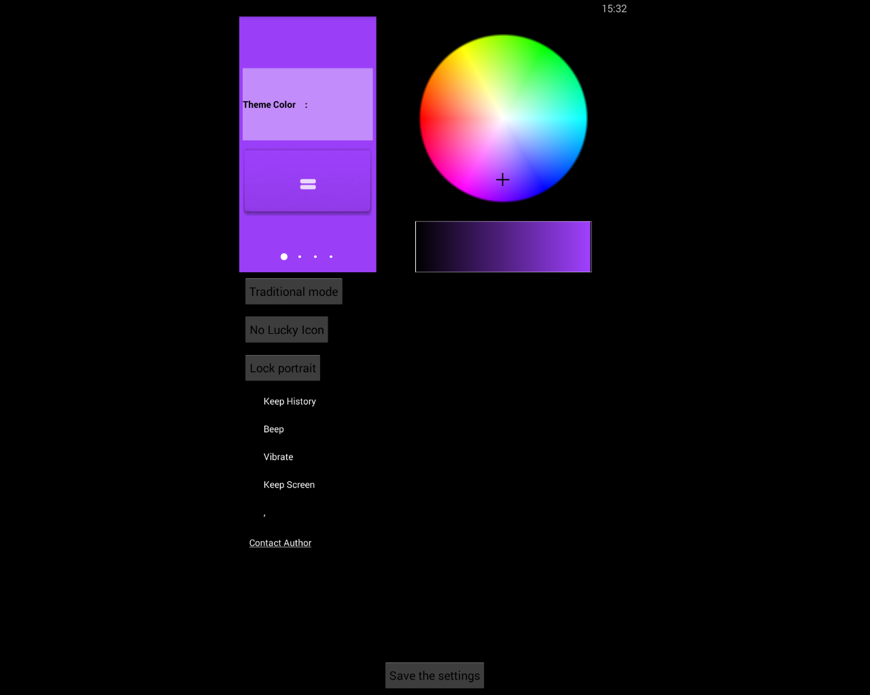

*The range of different colours that can be selected*

The app can be customised using a colour wheel that changes the general theme of the rest of the app. Although this feature does add customisability to the app which is a positive, the potential customisation is largely unprofessional and gaudy making it ill-suited for an app that will be used in a work environment. Therefore, in my opinion, this feature would be largely pointless in my project.

This app does contain other advantages, such as the feature that includes a history of past calculations.

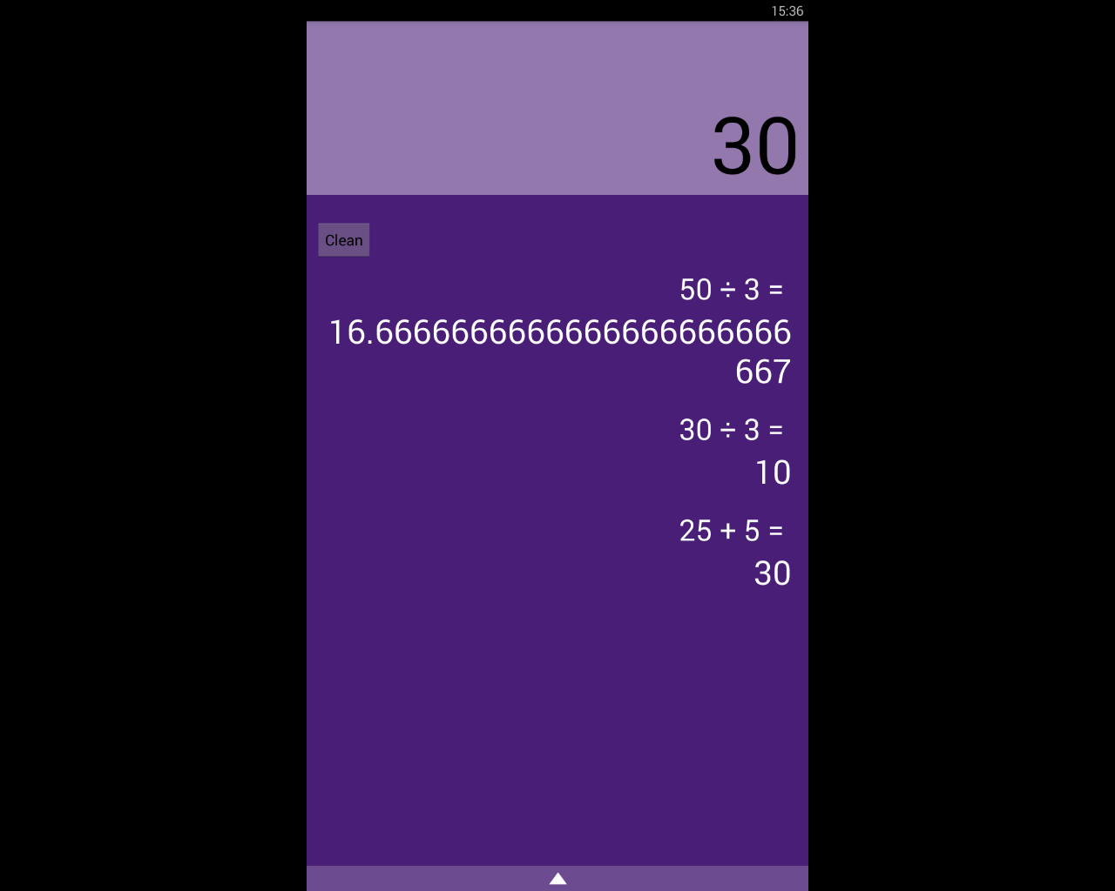

*The past calculations are shown*

This feature can be very useful because it allows the user to access and help remember what their past calculations are, and so reduces the chance of the user losing track of what they’re doing.

## Requirements for the Solution

Requirements for my solution can be split into two sections, the requirements for myself as the developer and for the user.

### 1.4.1 Developer’s Requirements

The resources required for the solution to be developed will include things like:

* A computer with the capability to run Java. This is because I will be programming the project in Java due to the language’s versatility and because I am very familiar with it. This computer will need to have no limitations or restrictions on the internet usage and will require full admin access.
* An Android virtual machine. This will be used to test my program without having to use a physical phone which will make the process quicker and more efficient.
* An Android phone with the required minimum specifications. This will be used for testing of the project, so I can find out how the program runs on actual phones and use it to bug fix my program.
* Testers. I will require GCSE students to test my program on because they are the primary stakeholder and, so it will be important to test my program on them to take their criticisms into account to make the program as useful and successful as possible.
* Access to wherever the app is hosted, for example the Google Play Store so the app can be accessed easily by the users.

### 1.4.2 User’s Requirements

The user’s requirements will differ greatly from the developer’s. Their requirements will contain:

* An Android phone with the minimum specifications requirements, including the correct version of Android. This will mean that they will be capable of running the program without crashing or otherwise harming their phone. Also, their phone will need to have the correct resolution so that the program can be displayed clearly, and the UI is properly presented and is easily used and intuitive.
* A stable internet connection. This will be required so that the user can download the app from wherever it is hosted and also to potentially download updates.

## Limitations of the Proposed Solution

My proposed solution will, unfortunately, have some limitations. For example, my project will likely have the limitation of not having functionality for graphs. While having the ability of drawing graphs in the app would be very useful, I think it will be very difficult to be able to include this feature.

This is because implementing the feature will have more difficulties to overcome than other, more simple features. Also, graph functionality is less of a priority compared to other features that are simply more important.

This can be seen in that there are dedicated apps to just graphs, showing that it is very complex to make well. Because of this, I think that if I try to implement graph functionality, other parts of my project will suffer.

Another limitation that is likely to occur is that the app itself may end up with an ugly user interface. This is because I am lacking when it comes to making artful and attractive design. Therefore, to overcome this potential limitation, I will certainly make often checks and tests with other people such as potential users. This will ensure that the final product will have an attractive design that is easy to use and intuitive.

## Success Criteria and Essential Features

The success criteria for my project can be broken down into basic features that are critical to the apps success and more advanced ones that, while still important, the app can function without.

### 1.6.1 Basic Success Criteria

* Functionality for the four basic operators, +, -, x, ÷. This will be of the utmost importance because without this, the calculator will not work at even the most basic level.
* The calculator will follow the rules of BODMASS. This feature is very important because it makes the experience more streamlined for the user because they don’t have to concern themselves about the formatting. Also, it will allow users to be more familiar with the app as they will be used to calculators following BODMASS.
* Have functionality for using square roots and powers. This feature will increase the amount of calculations the user is able to perform.
* Be able to use sin, cos, and tan and the inverses of. This is feature is required because it will enable the user to do trigonometry related functions which are a very large part of the maths GCSE.
* Cursor controls that will move the cursor around the equation. This is required because it allows the user more freedom and enables the user to edit equations.
* Capability for common forms of notation, such as standard form, fractions, decimals, etc. This is essential to the app because it will allow the calculator to be more understandable for the user.
* I will use a survey that asks people that have used the application to rate the usability and intuitiveness of the GUI. If at least 80% of the answers give positive feedback, I will consider this success criteria completed. I can also use this feedback to improve upon the design in later development iterations.

### 1.6.2 Advanced Success Criteria

* Displaying tips when the user access more niche and unknown features. This feature will be very beneficial because it will help users who are less computer literate and therefore increases the accessibility to a higher proportion of the potential user base.
* Detailed, helpful error messages that inform the user. This is important because it enables the user to use the app in a more productive way and therefore improves the apps usefulness.
* The capability to change the layout of the app to accommodate users with less common device sizes. This feature is important because it will allow a larger percentage of users to be able to interact properly with the app.
* Conversions between different base number systems, namely, binary, hexadecimal, and denary. This will be a useful feature as conversions between number systems feature heavily in the Computer Science GCSE and therefore will be helpful to GCSE students.
* Conversions between different units, such as miles to kilometres. This feature will be very beneficial to the app because it will streamline the user’s process when doing calculations because less time will be needed to be spent doing conversions.